CHAPTER
ADVANCES IN BRAIN-COMPUTER INTERFACES: FROM NEURAL SIGNALS TO MACHINE LEARNING AND ETHICS

How to Use This Chapter

This chapter is structured to guide readers from basic concepts to advanced applications in neuroengineering and brain-computer interfaces (BCIs). You can read it sequentially for a comprehensive understanding or jump to specific sections based on your interest.
- Beginners should start from the introduction and follow through to build a solid foundation.
- Advanced learners may focus on signal processing (Section 5), machine learning (Section 6), and applications (Section 7).
References are organized in section-based blocks (e.g., [101] – [199] for Section 1, [201] – [299] for Section 2, etc.) for easier tracking and to avoid confusion. Repeated references retain the same number.
This structure ensures clarity, learning flexibility, and efficient knowledge building.

Table of Contents:

1 Introduction
1.1 Definition of Neuroengineering
1.2 Importance of BCI in modern healthcare
2 Basic Human Brain Physiology
2.1 Brain structure overview
2.2 Neural signal transmission
3 Types of Brain Signals Used in BCI
3.1 Electroencephalography (EEG)
3.2 Electrocorticography (ECoG)
3.3 Intracortical Signals (Single-unit and Multi-unit Recordings)
3.4 Magnetoencephalography (MEG)
3.5 Functional Near-Infrared Spectroscopy (fNIRS)
3.6 Local Field Potentials (LFPs)
4 Signal Acquisition Technologies in Brain-Computer Interfaces
4.1 Electrodes and Sensor Types
4.2 Amplifier and Filters
4.3 Analog-to-Digital Conversion (ADC)
4.4 Wearable and Implantable Devices
4.5 Noise and Artifact Handling
5 Signal Processing and Feature Extraction in BCIs
5.1 Preprocessing of Brain Signals
5.2 Time-Domain Feature Extraction
5.3 Frequency-Domain Feature Extraction
5.4 Time-Frequency Analysis
5.5 Spatial Filtering
5.6 Source Localization
5.7 Deep Feature Learning
6 Machine Learning and Classification in BCIs
6.1 Traditional Classifiers
6.2 Ensemble and Hybrid Methods
6.3 Deep Learning Approaches
6.4 Model Evaluation and Metrics
7 Application of Brain-Computer Interfaces
7.1 Clinical and Rehabilitation Applications
7.2 Cognitive and Affective Computing
7.3 Gaming and Entertainment
7.4 Smart Environments and Assistive Technologies
7.5 Emerging Applications
8 Ethical Considerations and Future Directions
8.1 Ethical Considerations in Brain-Computer Interfaces
8.2 Regulatory and Legal Challenges
8.3 Future Directions
9 Conclusion and Future Perspectives
10 References
11 Image Credit Section
12 Abbreviations

- Introduction

  - Definition of Neuroengineering

Neuroengineering, also known as neural engineering, is an interdisciplinary field that merges principles from neuroscience, engineering, and computer science to understand, repair, enhance, or interface with neural systems. It focuses on developing tools and technologies to interact with the nervous system, often through hardware and software innovations that interpret or stimulate neural activity [101]. This field plays a key role in translating neuroscience discoveries into real-world applications, such as brain-computer interfaces, neuroprosthetics, and neuromodulation devices [102].
Neuroengineering is not limited to medical applications; it also has growing relevance in non-clinical domains such as augmented reality, cognitive enhancement, and human-computer symbiosis [103]. Its rapid evolution is driven by advancements in neural recording technologies, machine learning algorithms, and miniaturized bioelectronics [104].

  - Importance of BCI in Modern Healthcare

A Brain-Computer Interface (BCI) facilitates direct interaction between neural activity and external systems, bypassing conventional neuromuscular pathways. BCIs interpret brain signals—usually electrical or metabolic—and convert them into commands that control software or hardware systems. This direct neural pathway bypasses the peripheral nervous system, enabling communication and control even when motor functions are impaired [105].
In modern healthcare, BCIs have shown transformative potential in assisting patients with severe motor disabilities, such as those caused by amyotrophic lateral sclerosis (ALS), stroke, or spinal cord injuries. For these individuals, BCI technology can restore basic communication, enable wheelchair control, or operate robotic limbs, significantly improving quality of life [106]. Additionally, BCIs are being explored for rehabilitation purposes, where feedback-based neural stimulation can help rewire damaged neural pathways [107].
Beyond mobility assistance, BCIs are emerging as diagnostic and therapeutic tools in neuropsychiatry, for example in managing conditions like epilepsy, depression, or ADHD, using real-time brain monitoring and stimulation [108].
The integration of artificial intelligence with BCI systems further enhances their performance and adaptability, making them more accurate, user-friendly, and responsive to individual neural patterns [109]. With these advancements, BCI is increasingly viewed as a frontier of personalized medicine and neurorehabilitation.

- Basic Human Brain Physiology

Understanding the physiological structure and functioning of the human brain is essential to comprehend how neuroengineering and brain-computer interfaces (BCIs) interact with neural systems. This section covers two foundational aspects: the brain's anatomical structure and the mechanism of neural signal transmission.

  - Brain Structure Overview

Weighing about 1.4 kilograms, the human brain is an incredibly intricate organ, consisting of nearly 86 billion neurons that govern bodily functions and cognition. The brain consists of several key functional areas, including the cerebrum, cerebellum, and brainstem, each contributing distinct roles in neural processing. The cerebrum, the brain’s largest region, consists of two hemispheres, each subdivided into four primary lobes: frontal, parietal, temporal, and occipital, each responsible for distinct cognitive and sensory functions. Each lobe contributes to distinct functions, such as executive planning, sensory integration, memory processing, and visual interpretation, respectively [201].
Beneath the cerebrum lies the cerebellum, which plays a crucial role in refining movement accuracy, maintaining posture, and ensuring motor coordination. Despite occupying only about 10% of the brain's volume, it contains more than half of all neurons [202].
The brainstem connects the brain to the spinal cord and governs vital involuntary functions such as breathing, heart rate, and sleep-wake cycles.
Each region is structured into gray matter, which consists primarily of neuronal cell bodies, and white matter, composed of axons insulated by myelin sheaths that facilitate long-distance signal transmission.
Additionally, the brain is protected and nourished by cerebrospinal fluid (CSF), the meninges (three protective layers), and the blood-brain barrier (BBB), which regulates the passage of substances between the bloodstream and brain tissue [203].
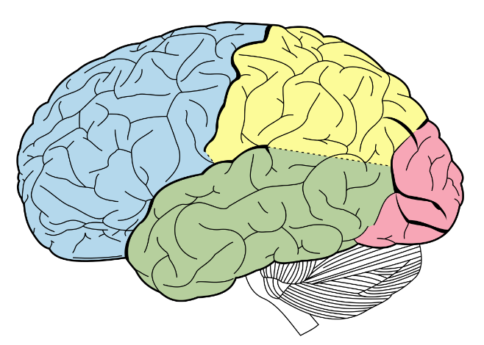
Figure 1 Lobes of the brain illustration. Source: Wikimedia Commons. Image by Unknown licensed under public domain.

  - Neural Signal Transmission

Neurons communicate via electrochemical signals. Neurons are composed of dendrites that gather signals, a cell body (soma) that processes information, and an axon that conveys the response to target cells.
Neural signal transmission starts when a stimulus alters the neuron's membrane potential, triggering an action potential. The action potential propagates through the axon to its terminals, prompting the discharge of neurotransmitters into the synapse to influence the next neuron. These chemicals bind to receptors on adjacent neurons, propagating the signal [204].
The resting potential of a neuron is maintained at around -70 mV due to the differential distribution of ions (mainly Na⁺ and K⁺) across the membrane. The sodium-potassium pump and voltage-gated ion channels play vital roles in generating and resetting action potentials [205].
Neurons can form networks of complex connectivity, and through synaptic plasticity—the strengthening or weakening of synapses—they enable learning and memory. Neural plasticity manifests in two key forms: long-term potentiation (LTP), which strengthens synaptic connections, and long-term depression (LTD), which weakens them, both playing crucial roles in learning and memory formation. [206].
Glial cells, often underemphasized, are crucial for supporting neurons. Types include astrocytes (regulate the extracellular environment), oligodendrocytes (form myelin in CNS), microglia (immune defence), and Schwann cells (myelin in PNS) [207].
From a BCI perspective, understanding the mechanisms of neural signalling helps in identifying how and where to record signals effectively, especially in non-invasive (like EEG) or invasive (like ECoG or intracortical) methods.

- Types of Brain Signals Used in Brain-Computer Interfaces

The human brain produces diverse electrical signals driven by neuronal activity. Brain-Computer Interfaces (BCIs) depend on detecting and interpreting these signals to infer a user's intentions or mental state. Understanding the different types of brain signals is essential for designing effective BCI systems. These signals differ in their spatial and temporal resolution, signal-to-noise ratio (SNR), invasiveness, and ease of decoding.

  - Electroencephalography (EEG)

Electroencephalography (EEG) is a commonly used non-invasive method for monitoring brain activity. It detects voltage changes resulting from synchronized neuronal activity through electrodes positioned on the scalp. EEG signals are categorized into distinct frequency bands, including delta (0.5–4 Hz), theta (4–8 Hz), alpha (8–13 Hz), beta (13–30 Hz), and gamma (above 30 Hz), each associated with different brain functions. [301]. EEG offers excellent temporal resolution in the millisecond range, making it ideal for real-time monitoring. The skull and scalp introduce distortions that restrict the spatial accuracy of this technique, affecting signal clarity. Additionally, EEG recordings are prone to interference from muscle movements, eye activity, and external electrical noise [302].

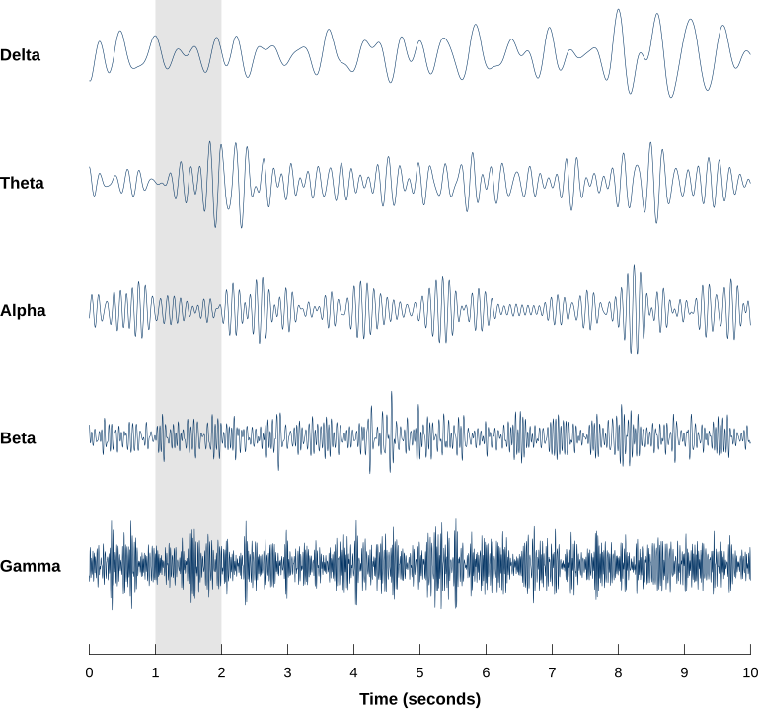
Figure 2 EEG Brainwaves
Source: Wikimedia Commons. Image by Laurens R. Krol licensed under CC0 1.0.

Despite limitations, EEG is preferred for BCI applications due to its non-invasiveness, portability, and low cost. It is commonly used for motor imagery, P300, and steady-state visually evoked potential (SSVEP)-based BCIs [303].

  - Electrocorticography (ECoG)

Electrocorticography (ECoG) requires electrodes to be placed directly on the brain’s cortical surface, often during neurosurgical interventions. This method balances the level of invasiveness with enhanced signal precision, ensuring reliable neural recordings. Compared to EEG, ECoG delivers enhanced spatial and spectral resolution, along with a superior signal-to-noise ratio, making it a valuable tool for precise neural recordings [304].
ECoG has been successfully used in BCIs for motor control and speech decoding due to its access to higher-frequency brain activity (>70 Hz, or high gamma) [305]. However, since it requires craniotomy, its use is mostly limited to clinical or research environments.

  - Intracortical Signals (Single-unit and Multi-unit Recordings)

Intracortical BCIs use microelectrode arrays (such as the Utah array) implanted into the cortical tissue to capture action potentials (spikes) from individual or multiple neurons. These signals offer the highest spatial and temporal resolution, enabling precise decoding of motor intentions or sensory feedback [306].
Such systems have enabled paralyzed patients to control robotic arms or cursors with high accuracy [307]. However, their long-term use is challenged by issues like tissue response (gliosis), electrode degradation, and the risk of infection or inflammation [308].

  - Magnetoencephalography (MEG)

Magnetoencephalography (MEG) detects magnetic fields produced by neural activity using highly sensitive superconducting quantum interference devices (SQUIDs), enabling detailed brain function analysis. It provides better spatial resolution than EEG and maintains high temporal resolution [309].
Magnetoencephalography (MEG) devices, while highly sensitive, tend to be large, costly, and require specialized rooms shielded from magnetic interference. Their use in BCI is limited primarily to research contexts, though advances in optically pumped magnetometers may enable portable MEG in the future [309].

  - Functional Near-Infrared Spectroscopy (fNIRS)

Functional near-infrared spectroscopy (fNIRS) is a non-invasive optical method that tracks brain activity by detecting changes in blood oxygen levels through near-infrared light absorption. It provides indirect measures of neural activity, similar to fMRI, but with lower cost and portability [310].
fNIRS has relatively poor temporal resolution (~seconds), making it unsuitable for fast-feedback BCIs. However, it is useful in hybrid BCI systems when combined with EEG for improved accuracy and robustness [311].

  - Local Field Potentials (LFPs)

LFPs are low-frequency electrical signals (<500 Hz) recorded from electrodes implanted in the brain. They reflect the summed synaptic activity of neurons near the electrode. LFPs provide insights into the network-level dynamics and are widely used in animal models and human BCI experiments [312].
LFPs strike a balance between spike recordings and ECoG in terms of invasiveness and resolution. Their role is especially important in decoding cognitive and motor intentions for closed-loop neuroprosthetics [313].

- Signal Acquisition Technologies in Brain-Computer Interfaces

Accurate acquisition of brain signals is a critical step in Brain-Computer Interface (BCI) systems. The performance of a Brain-Computer Interface (BCI) is strongly influenced by how accurately and consistently neural signals are recorded. Different technologies are used to acquire signals depending on the BCI type (invasive vs. non-invasive), target brain region, and application scenario. This section outlines the hardware and methods used for signal acquisition in both clinical and non-clinical settings.

  - Electrodes and Sensor Types

    - Wet Electrodes

Wet electrodes utilize conductive gels or pastes to enhance connectivity with the skin, minimizing impedance at the electrode interface. Silver/Silver Chloride (Ag/AgCl) electrodes are commonly used in EEG systems due to their stability and biocompatibility [401]. While they offer excellent signal quality, their preparation is time-consuming and they are not ideal for long-term or wearable applications.

    - Dry Electrodes

Dry electrodes offer a convenient alternative to traditional wet electrodes by removing the need for conductive gels, which enhances user comfort and speeds up the setup process. They typically use conductive materials such as gold, titanium, or conductive polymers [402]. While easy to use, these electrodes tend to have elevated impedance levels and are more susceptible to disturbances caused by movement.

    - Semi-Dry and Hybrid Electrodes

Semi-dry electrodes offer a middle ground between wet and dry types, incorporating small amounts of electrolytes or moisture-retaining substances to maintain signal quality These electrodes offer a balance of signal quality and usability and are gaining popularity in wearable EEG systems [403].

    - Microelectrode Arrays

Used in intracortical BCIs, microelectrode arrays (MEAs) such as the Utah array are capable of recording single-unit or multi-unit activity from individual neurons. They typically consist of 96–128 silicon needles implanted into the cortical tissue [404]. These provide high-resolution data but are invasive and require surgical implantation.

    - Optoelectronic Sensors

Optical sensors used in fNIRS or other biophotonic methods detect changes in blood oxygenation or tissue optical properties. These include light-emitting diodes (LEDs) and photodetectors arranged in pairs on the scalp [405].

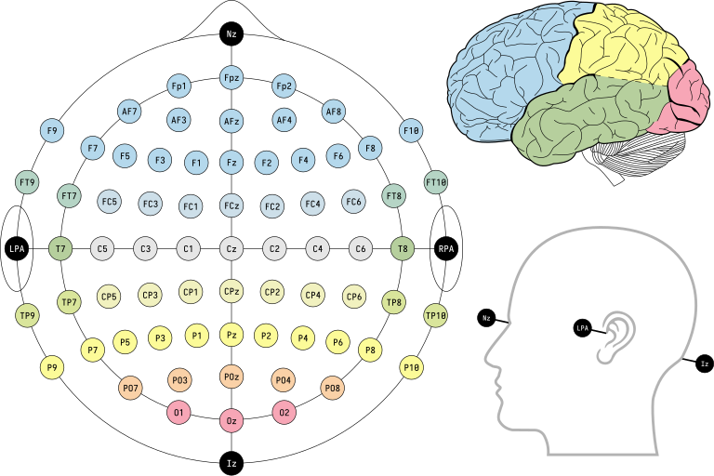
Figure 3 Electrode placements in the international 10-10 EEG system, including standard and intermediate positions.
Source: Wikimedia Commons. Image by Laurens R. Krol licensed under CC0 1.0.

  - Amplifiers and Filters

Brain signals are inherently weak, ranging from microvolts (EEG) to millivolts (ECoG, LFP). Amplification is necessary to boost these signals without distortion. High-input impedance, low-noise differential amplifiers are used to preserve signal integrity [406].
Filters are essential to eliminate noise, such as:
• Low-pass filters (to remove high-frequency noise)
• High-pass filters (to eliminate drift or DC components)
• Notch filters (commonly used to remove 50/60 Hz powerline interference)
Signal conditioning is typically performed on hardware before digitization to ensure cleaner data for processing.

  - Analog-to-Digital Conversion (ADC)

Following amplification and filtering, the analog brain signal is digitized using an ADC. Choosing the appropriate sampling rate and bit resolution depends on the specific brain signal being recorded:
• EEG signals typically require sampling rates between 250 and 1000 Hz with resolutions of 16 to 24 bits.
• Electrocorticography (ECoG) and Local Field Potentials (LFPs) often demand higher sampling frequencies, around 5 kHz.
• For intracortical spike recordings, very high sampling rates of 30 to 40 kHz are necessary to capture fast neuronal firing events [407].
Modern systems often use on-chip digitizers integrated with low-power signal processing units, especially in wearable or implantable devices.

  - Wearable and Implantable Devices

Advancements in miniaturization and wireless technology have enabled portable and wearable BCI systems.
• Wearable EEG headsets: Devices like Emotiv, OpenBCI, or Muse provide mobile EEG monitoring. Though limited in channel count and signal fidelity, they are suitable for non-critical applications [408].
• Implantable BCI systems: Devices such as Neuralink's "Link" or BrainGate systems embed microelectronics inside the skull, enabling real-time signal streaming with high resolution and low latency [409].
These devices often integrate wireless telemetry, rechargeable batteries, and even signal preprocessing capabilities to enable real-world use.

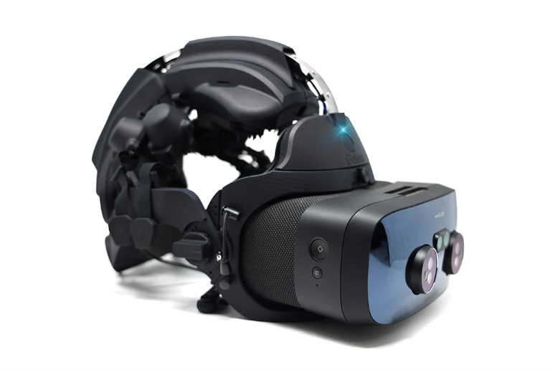
Figure 4 The OpenBCI Galea device mounted with a Varjo XR-3 HMD.
Source: Wikimedia Commons. Image by Carillons licensed under CC BY-SA 4.0.

  - Noise and Artifact Handling

Brain signals are highly susceptible to various artifacts, including:
• Electromyographic (EMG) noise from facial muscles
• Electrooculographic (EOG) signals from eye movements and blinks
• Motion artifacts due to user movement or electrode shifts
Advanced signal acquisition systems incorporate shielding, differential referencing, and active grounding to reduce noise. Additionally, preprocessing algorithms such as Independent Component Analysis (ICA) and regression-based artifact removal are used in software stages [410].

- Signal Processing and Feature Extraction in BCIs

Once raw brain signals are acquired, they must undergo extensive processing to extract meaningful features that correlate with the user’s intention or mental state. Signal processing and feature extraction are crucial stages in the BCI pipeline, determining the accuracy, speed, and robustness of the system. This section covers fundamental signal processing methods and feature extraction techniques tailored to various brain signal types and application needs.

  - Preprocessing of Brain Signals

Preprocessing removes noise and artifacts while standardizing the data for analysis. It typically includes the following steps:

    - Artifact Removal

• Independent Component Analysis (ICA): Decomposes mixed signals into statistically independent sources, allowing the removal of artifacts such as eye blinks and muscle activity [501].
• Regression Methods: Model artifact signals (e.g., from EOG/EMG channels) and subtract them from EEG recordings.
• Wavelet-based denoising eliminates transient noise while maintaining the integrity of time-frequency features in the signal [502].

    - Filtering

• Bandpass Filtering: EEG signals are filtered into specific frequency bands:
• Delta (0.5–4 Hz): Deep sleep
• Theta (4–8 Hz): Drowsiness
• Alpha (8–13 Hz): Relaxed alertness
• Beta (13–30 Hz): Active thinking
• Gamma (30–100 Hz): High-level cognition [503]
• Notch Filtering: Removes power line noise (50/60 Hz).

    - Normalization and Baseline Correction

• This step reduces individual variability in brain signals by standardizing the mean and variance or subtracting resting-state baselines.

  - Time-Domain Feature Extraction

• Time-domain features, while straightforward, are effective and widely used for applications requiring real-time processing.
• Statistical amplitude-related measures—including mean, variance, skewness, and kurtosis—offer crucial insights into signal characteristics and their underlying patterns.
• Hjorth descriptors help analyze signal attributes such as activity, mobility, and complexity, playing a vital role in extracting features.• Event-Related Potentials (ERP): Voltage deflections (e.g., P300, N200) time-locked to stimuli, often used in speller BCIs or attention detection [504].

  - Frequency-Domain Feature Extraction

• Frequency-based features reveal oscillatory brain dynamics.
• Power Spectral Density (PSD): Estimates signal power across frequency bands using methods like Fast Fourier Transform (FFT) or Welch’s method.
• Band Power Ratios: Ratios such as alpha/beta or theta/beta help classify cognitive or emotional states [505].
• Spectral Entropy: Measures signal randomness or complexity in frequency space.

  - Time-Frequency Analysis

• Many cognitive processes are brief and dynamic, necessitating analysis methods that simultaneously capture both temporal and frequency characteristics.
• Short-Time Fourier Transform (STFT): Applies FFT in sliding windows.
• Wavelet Transform (WT): Captures time-localized frequency features, ideal for non-stationary brain signals like EEG [506].
• Hilbert-Huang Transform (HHT): A data-driven technique that adaptively breaks down complex signals into intrinsic mode functions (IMFs), allowing detailed analysis of non-linear and non-stationary data.

  - Spatial Filtering

• Spatial filters enhance signal quality by combining information across electrodes.
• Common Spatial Patterns (CSP): Maximizes variance between two classes (e.g., left vs. right motor imagery) [507].
• Laplacian Filtering: Enhances local activity by subtracting neighbouring signals.
• Independent Component Analysis (ICA): (already mentioned in preprocessing) is also used to extract task-related components.

  - Source Localization (Advanced)

• Source localization methods attempt to infer the location of neural sources from scalp signals:
• Low Resolution Electromagnetic Tomography (LORETA)
• Beamforming Techniques
• Dipole Fitting Algorithms
• These methods are computationally intensive and often used in research rather than real-time BCIs.

  - Deep Feature Learning (Modern Approach)

• Recent advances in BCI research have shown promise using deep learning for feature extraction:
• Convolutional Neural Networks (CNNs): Automatically learn spatial and temporal patterns from raw EEG or spectrograms [508].
• Recurrent Neural Networks (RNNs): Model temporal dependencies and sequences in EEG data.
• Autoencoders and Transformers: Extract compact, high-level representations from brain signals.
• Deep models reduce the need for hand-crafted features, but require large datasets and significant training.

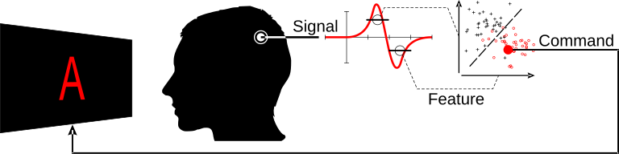
Figure 5 Brain-computer interface diagram.
Source: Wikimedia Commons. Image by Laurens R. Krol licensed under CC0 1.0.

- Machine Learning and Classification in BCIs

Machine learning (ML) plays a pivotal role in Brain-Computer Interfaces (BCIs) by enabling the system to decode brain signals and translate them into meaningful commands. Since raw brain signals are complex, noisy, and non-stationary, ML algorithms help in extracting useful patterns and classifying mental states or intentions effectively.

  - Traditional Classifiers

Early BCI systems primarily used classical ML algorithms for classification due to their simplicity and interpretability. Some commonly used classifiers include:
• Linear Discriminant Analysis (LDA): It is widely popular because of its computational efficiency and good performance on EEG data, especially for binary classification tasks such as motor imagery [601][602].
• Support Vector Machines (SVM): SVMs are effective in high-dimensional feature spaces and have been applied to various BCI paradigms including multi-class problems [603].
• k-Nearest Neighbours (k-NN): A simple instance-based learning method, useful for small datasets, but less common in real-time BCIs due to computational overhead [604].
• Naive Bayes: Utilized in some studies for its probabilistic framework, though it assumes feature independence, which rarely holds in brain signals [605].

  - Ensemble and Hybrid Methods

To improve classification robustness, ensemble learning combines multiple models, leveraging their collective decisions:
• Bagging and Boosting: Techniques like Random Forests and AdaBoost have shown improved accuracy by reducing variance and bias [606].
• Hybrid classifiers: Some systems merge classifiers (e.g., combining SVM with LDA) or fuse features from multiple modalities (EEG + EMG) to enhance performance [607].

  - Deep Learning Approaches

The rise of deep learning has revolutionized BCI signal processing by automatically learning complex features from raw data, reducing the need for handcrafted features:
• Convolutional Neural Networks (CNNs): CNNs capture spatial and temporal patterns in EEG signals and have been used for motor imagery and event-related potentials classification [608].
• Recurrent Neural Networks (RNNs): RNNs and their variants like Long Short-Term Memory (LSTM) networks model temporal dependencies in sequential brain data effectively [609].
• Autoencoders and Generative Models: These unsupervised models assist in feature extraction and data augmentation for scarce datasets [610].
Deep models often outperform traditional classifiers but require larger datasets and greater computational resources.

  - Model Evaluation and Metrics

Evaluating ML models in BCIs involves metrics that assess accuracy, robustness, and real-time usability:
• Accuracy: Percentage of correctly classified instances; commonly reported but insufficient alone.
• Confusion Matrix: Provides detailed insight into true positives, false positives, etc.
• Precision, Recall, F1-Score: Important in imbalanced datasets.
• Information Transfer Rate (ITR) quantifies the efficiency of Brain-Computer Interface (BCI) communication by evaluating both accuracy and transmission speed in bits per minute [611].
• Cross-validation: Used to avoid overfitting, ensuring model generalization across sessions and users.
In real-world BCIs, latency and computational cost are also critical performance factors.

- Applications of Brain-Computer Interfaces

Brain-Computer Interfaces (BCIs) have seen rapid advancements and diverse applications across healthcare, communication, entertainment, and beyond. This section explores the major domains where BCIs are transforming human-machine interaction.

  - Clinical and Rehabilitation Applications

BCIs are extensively used to restore or enhance function in patients with neurological disorders:
• Neuroprosthetics: BCIs enable direct control of prosthetic limbs by decoding motor intentions from brain signals, helping amputees regain mobility [701][702].
• Communication Aids: For patients with severe paralysis (e.g., Locked-In Syndrome, ALS), BCIs provide communication pathways by translating brain activity into text or speech commands [703].
• Stroke Rehabilitation: Closed-loop BCIs facilitate motor recovery by coupling brain activity with robotic exoskeletons or functional electrical stimulation, promoting neuroplasticity [704].
• Epilepsy Monitoring and Control: Real-time detection of seizure precursors via BCIs can trigger interventions to prevent or reduce seizure severity [705].

  - Cognitive and Affective Computing

BCIs enable the monitoring and adjustment of brain activity associated with emotional and cognitive functions.
• Attention Monitoring: EEG-based BCIs can monitor vigilance levels in pilots or drivers to reduce accidents due to fatigue or distraction [706].
• Stress and Emotion Recognition: Real-time emotion detection through BCIs aids mental health applications, gaming, and adaptive interfaces [707].
• Neurofeedback Training: Users learn to self-regulate brain activity patterns to treat ADHD, anxiety, or improve focus and relaxation [708].

  - Gaming and Entertainment

BCIs are being actively investigated for their potential to elevate user engagement in immersive gaming and interactive entertainment platforms.
• Hands-Free Control: Players can control game characters or environments using thought patterns, enabling novel interaction modes [709].
• Virtual Reality (VR) Integration: BCIs integrated with VR offer enhanced immersion and adaptive experiences based on user mental states [710].
• Adaptive Content: Real-time emotional and cognitive feedback allows games and media to tailor difficulty and content dynamically.

  - Smart Environments and Assistive Technologies

Brain-Computer Interfaces contribute to building smart environments and enhancing accessibility for individuals with physical or cognitive impairments.
• Home Automation: Control of lights, appliances, or wheelchairs through brain signals improves independence for people with mobility impairments [711].
• Augmented Cognition: BCIs can augment human capabilities by predicting and adapting to user intentions in complex tasks [712].
• Educational Tools: Adaptive learning platforms powered by BCI-based attention and engagement monitoring personalize educational content [713].

  - Emerging Applications

Recent developments push BCIs into new frontiers:
• Brain-to-Brain Communication: Experimental studies demonstrate direct transmission of information between brains via BCI networks [714].
• Neuroenhancement: Use of BCIs to enhance memory, learning, or cognitive abilities in healthy individuals is an active research area [715].
• Hybrid BCIs: Combining invasive and non-invasive methods, or integrating AI, to improve accuracy and usability [716].

- Ethical Considerations and Future Directions

  - Ethical Considerations in Brain-Computer Interfaces

As BCIs evolve, ethical issues become critical to ensure responsible development and deployment:
• Privacy and Data Security: Brain signals contain highly sensitive personal information. Unauthorized access or misuse could lead to privacy breaches, discrimination, or psychological harm [801][802].
• Informed Consent: Given the complex nature of BCIs, users must be fully informed about potential risks, benefits, and limitations before consenting to use, especially in clinical contexts [803].
• BCIs can challenge the distinction between a user’s genuine intent and the system’s automated responses, raising concerns about personal autonomy and agency. Protecting users’ autonomy and preventing manipulation or coercion is vital [804].
• Equity and Access: High costs and technological complexity risk creating disparities in access to BCI benefits, exacerbating social inequalities [805].
• Long-Term Effects: The long-term neurological and psychological impacts of invasive or prolonged BCI use remain under-researched, raising safety concerns [806].

  - Regulatory and Legal Challenges

BCIs operate at the intersection of medicine, technology, and human rights, necessitating updated regulatory frameworks:
• Standardization: There is a need for standards on device safety, interoperability, and data handling to protect users [807].
• Liability: Questions about liability arise when BCIs malfunction or cause unintended consequences, especially in autonomous control scenarios [808].
• Intellectual Property: Ownership of neural data and inventions derived from BCI use require clear legal guidelines [809].

  - Future Directions

The future of BCIs holds immense promise with ongoing research focusing on:
• Improved Signal Acquisition: Development of minimally invasive or non-invasive sensors with higher resolution and stability [810].
• AI Integration: Advanced machine learning algorithms for more accurate decoding, adaptive interfaces, and personalized BCI systems [811].
• Hybrid Systems: Combining multiple neural signals (EEG, fNIRS, intracortical) to enhance robustness and functionality [812].
• Neurofeedback and Closed-Loop Systems: Real-time feedback mechanisms that enable self-regulation and dynamic control for rehabilitation and enhancement [813].
• Brain-to-Cloud Interfaces: Direct connection of the brain to cloud computing resources for augmented cognition and memory expansion [814].
• Ethical AI and Governance: Embedding ethical AI principles into BCI development to ensure transparency, fairness, and user well-being [815].

- Conclusion and Future Perspectives

Brain-Computer Interfaces (BCIs) are innovative technologies that integrate principles from neuroscience, engineering, and artificial intelligence to establish direct pathways for interaction between the brain and external devices. Over the past decades, substantial advances have enhanced our ability to decode neural signals and translate them into meaningful commands, enabling communication, control, and even cognitive enhancement [901][904].
This chapter provided a comprehensive overview of BCI fundamentals, signal acquisition modalities, processing techniques, device architectures, and applications spanning healthcare, communication, entertainment, and neurorehabilitation. The integration of AI and machine learning has been crucial for improving BCI accuracy, adaptability, and user experience [904][906].
Ethical, legal, and social implications remain critical considerations as BCI technology progresses. Addressing concerns about privacy, autonomy, equity, and long-term safety will be essential for responsible adoption [901][902][903][908].
Looking forward, the fusion of multi-modal signals, advanced AI, and cloud connectivity promises to unlock unprecedented BCI capabilities such as brain-to-brain communication, real-time neurofeedback, and augmented cognition [905][907]. The integration of hybrid systems and closed-loop architectures is expected to enhance the reliability and therapeutic effectiveness of BCIs, thereby expanding their applications in both healthcare and consumer sectors [906].
Continued interdisciplinary collaboration among neuroscientists, engineers, ethicists, and policymakers is vital to navigate technical challenges and societal impact. The future of BCIs is poised to profoundly enhance human-computer interaction and redefine our relationship with technology and ourselves.

- References

[101] He, B., et al. (2013). Grand challenges in interfacing engineering with life sciences and medicine. IEEE Transactions on Biomedical Engineering, 60(3), 589–598. https://doi.org/10.1109/TBME.2013.2244889
[102] Lebedev, M. A., & Nicolelis, M. A. (2006). Brain–machine interfaces: past, present and future. Trends in Neurosciences, 29(9), 536–546. https://doi.org/10.1016/j.tins.2006.07.004
[103] Yuste, R., et al. (2017). Four ethical priorities for neurotechnologies and AI. Nature, 551(7679), 159–163. https://doi.org/10.1038/551159a
[104] Elon Musk et al. (2021). An integrated brain-machine interface platform with thousands of channels. Journal of Medical Internet Research, 23(6), e16194. https://doi.org/10.2196/16194
[105] Wolpaw, J. R., & Wolpaw, E. W. (2012). Brain-Computer Interfaces: Principles and Practice. Oxford University Press.
[106] Chaudhary, U., et al. (2016). Brain–computer interface–based communication in the completely locked-in state. PLoS Biology, 14(1), e1002561. https://doi.org/10.1371/journal.pbio.1002561
[107] Biasiucci, A., et al. (2018). Brain-actuated functional electrical stimulation elicits lasting arm motor recovery after stroke. Nature Communications, 9(1), 1–13. https://doi.org/10.1038/s41467-018-04673-z
[108] Sitaram, R., et al. (2017). Closed-loop brain training: the science of neurofeedback. Nature Reviews Neuroscience, 18(2), 86–100. https://doi.org/10.1038/nrn.2016.164
[109] Roy, Y., et al. (2019). Deep learning-based electroencephalography analysis: a systematic review. Journal of Neural Engineering, 16(5), 051001. https://doi.org/10.1088/1741-2552/ab260c
[201] Kandel, E. R., Schwartz, J. H., Jessell, T. M., Siegelbaum, S. A., & Hudspeth, A. J. (2013). Principles of Neural Science (5th ed.). McGraw-Hill.
[202] D'Angelo, E. (2018). The cerebellum gets social: Evidence from non-motor networks and clinical disorders. Cerebellum, 17(2), 152–165. https://doi.org/10.1007/s12311-017-0871-1
[203] Abbott, N. J., Patabendige, A. A., Dolman, D. E., Yusof, S. R., & Begley, D. J. (2010). Structure and function of the blood–brain barrier. Neurobiology of Disease, 37(1), 13–25. https://doi.org/10.1016/j.nbd.2009.07.030
[204] Purves, D., Augustine, G. J., Fitzpatrick, D., et al. (2018). Neuroscience (6th ed.). Oxford University Press.
[205] Hille, B. (2001). Ion Channels of Excitable Membranes (3rd ed.). Sinauer Associates.
[206] Nicoll, R. A. (2017). A brief history of long-term potentiation. Neuron, 93(2), 281–290. https://doi.org/10.1016/j.neuron.2016.12.015
[207] Allen, N. J., & Lyons, D. A. (2018). Glia as architects of central nervous system formation and function. Science, 362(6411), 181–185. https://doi.org/10.1126/science.aat0473
[301] Niedermeyer, E., & da Silva, F. L. (2005). Electroencephalography: Basic Principles, Clinical Applications, and Related Fields. Lippincott Williams & Wilkins.
[302] Fatourechi, M., Bashashati, A., Ward, R. K., & Birch, G. E. (2007). EMG and EOG artifacts in brain computer interface systems: A survey. Clinical Neurophysiology, 118(3), 480–494. https://doi.org/10.1016/j.clinph.2006.10.019
[303] Wolpaw, J. R., & Wolpaw, E. W. (2012). Brain-Computer Interfaces: Principles and Practice. Oxford University Press.
[304] Miller, K. J. (2010). Broadband spectral change: Evidence for a macroscale correlate of population firing rate? Journal of Neuroscience, 30(19), 6477–6479. https://doi.org/10.1523/JNEUROSCI.0645-10.2010
[305] Herff, C., & Schultz, T. (2016). Automatic speech recognition from neural signals: A focused review. Frontiers in Neuroscience, 10, 429. https://doi.org/10.3389/fnins.2016.00429
[306] Hochberg, L. R., Serruya, M. D., Friehs, G. M., Mukand, J. A., Saleh, M., Caplan, A. H., ... & Donoghue, J. P. (2006). Neuronal ensemble control of prosthetic devices by a human with tetraplegia. Nature, 442(7099), 164–171. https://doi.org/10.1038/nature04970
[307] Willett, F. R., Avansino, D. T., Hochberg, L. R., Henderson, J. M., & Shenoy, K. V. (2021). High-performance brain-to-text communication via handwriting decoding. Nature, 593(7858), 249–254. https://doi.org/10.1038/s41586-021-03506-2
[308] Barrese, J. C., Rao, N., Paroo, K., Triebwasser, C., Vargas-Irwin, C., Franquemont, L., & Donoghue, J. P. (2013). Failure mode analysis of silicon-based intracortical microelectrode arrays in non-human primates. Journal of Neural Engineering, 10(6), 066014. https://doi.org/10.1088/1741-2560/10/6/066014
[309] Hari, R., & Puce, A. (2017). MEG-EEG Primer. Oxford University Press.
[310] Boto, E., Holmes, N., Leggett, J., Roberts, G., Shah, V., Meyer, S. S., ... & Brookes, M. J. (2018). Moving magnetoencephalography towards real-world applications with a wearable system. Nature, 555(7698), 657–661. https://doi.org/10.1038/nature26147
[311] Ferrari, M., & Quaresima, V. (2012). A brief review on the history of human functional near-infrared spectroscopy (fNIRS) development and fields of application. NeuroImage, 63(2), 921–935. https://doi.org/10.1016/j.neuroimage.2012.03.049
[312] Fazli, S., Mehnert, J., Steinbrink, J., Curio, G., Villringer, A., Müller, K. R., & Blankertz, B. (2012). Enhanced performance by a hybrid NIRS–EEG brain computer interface. NeuroImage, 59(1), 519–529. https://doi.org/10.1016/j.neuroimage.2011.07.084
[313] Buzsáki, G., Anastassiou, C. A., & Koch, C. (2012). The origin of extracellular fields and currents—EEG, ECoG, LFP and spikes. Nature Reviews Neuroscience, 13(6), 407–420. https://doi.org/10.1038/nrn3241
[314] Gilja, V., Pandarinath, C., Blabe, C. H., Nuyujukian, P., Simeral, J. D., Sarma, A. A., ... & Shenoy, K. V. (2015). Clinical translation of a high-performance neural prosthesis. Nature Medicine, 21(10), 1142–1145. https://doi.org/10.1038/nm.3953
[401] Tallgren, P., Vanhatalo, S., Kaila, K., & Voipio, J. (2005). Evaluation of commercially available electrodes and gels for recording of slow EEG potentials. Clinical Neurophysiology, 116(4), 799–806. https://doi.org/10.1016/j.clinph.2004.10.001
[402] Lopez-Gordo, M. A., Sanchez-Morillo, D., & Valle, F. P. (2014). Dry EEG electrodes. Sensors, 14(7), 12847–12870. https://doi.org/10.3390/s140712847
[403] Liao, L. D., Wang, I. J., Chen, S. F., Chang, J. Y., & Lin, C. T. (2011). Design, fabrication and experimental validation of a novel dry-contact sensor for measuring electroencephalography signals without skin preparation. Sensors, 11(6), 5819–5834. https://doi.org/10.3390/s110605819
[404] Maynard, E. M., Nordhausen, C. T., & Normann, R. A. (1997). The Utah intracortical electrode array: A recording structure for potential brain-computer interfaces. Electroencephalography and Clinical Neurophysiology, 102(3), 228–239. https://doi.org/10.1016/S0013-4694(96)95176-0
[405] Scholkmann, F., Kleiser, S., Metz, A. J., Zimmermann, R., Pavia, J. M., Wolf, M., & Wolf, U. (2014). A review on continuous wave functional near-infrared spectroscopy and imaging instrumentation and methodology. NeuroImage, 85, 6–27. https://doi.org/10.1016/j.neuroimage.2013.05.004
[406] Huigen, E., Peper, A., & Grimbergen, C. A. (2002). Investigation into the origin of the noise of surface electrodes. Medical and Biological Engineering and Computing, 40(3), 332–338. https://doi.org/10.1007/BF02344216
[407] Fetz, E. E. (2007). Volitional control of neural activity: implications for brain-computer interfaces. Journal of Physiology, 579(3), 571–579. https://doi.org/10.1113/jphysiol.2006.127142
[408] Hairston, W. D., Whitaker, K. W., Ries, A. J., Vettel, J. M., Bradford, J. C., Kerick, S. E., & McDowell, K. (2014). Usability of four commercially-oriented EEG systems. Journal of Neural Engineering, 11(4), 046018. https://doi.org/10.1088/1741-2560/11/4/046018
[409] Musk, E., & Neuralink. (2019). An integrated brain-machine interface platform with thousands of channels. Journal of Medical Internet Research, 21(10), e16194. https://doi.org/10.2196/16194
[410] Jung, T. P., Makeig, S., Humphries, C., Lee, T. W., McKeown, M. J., Iragui, V., & Sejnowski, T. J. (2000). Removing electroencephalographic artifacts by blind source separation. Psychophysiology, 37(2), 163–178. https://doi.org/10.1111/1469-8986.3720163
[501] Jung, T. P., et al. (2000). Removing electroencephalographic artifacts by blind source separation. Psychophysiology, 37(2), 163–178.
[502] Samar, V. J., Bopardikar, A., Rao, R., & Swartz, K. (1999). Wavelet analysis of neuroelectric waveforms: A conceptual tutorial. Brain and Language, 66(1), 7–60. https://doi.org/10.1006/brln.1998.2021
[503] Niedermeyer, E., & da Silva, F. L. (2005). Electroencephalography: Basic principles, clinical applications, and related fields. Lippincott Williams & Wilkins.
[504] Polich, J. (2007). Updating P300: An integrative theory of P3a and P3b. Clinical Neurophysiology, 118(10), 2128–2148. https://doi.org/10.1016/j.clinph.2007.04.019
[505] Harmony, T. (2013). The functional significance of delta oscillations in cognitive processing. Frontiers in Integrative Neuroscience, 7, 83. https://doi.org/10.3389/fnint.2013.00083
[506] Addison, P. S. (2017). The Illustrated Wavelet Transform Handbook: Introductory Theory and Applications in Science, Engineering, Medicine and Finance. CRC press.
[507] Ramoser, H., Müller-Gerking, J., & Pfurtscheller, G. (2000). Optimal spatial filtering of single trial EEG during imagined hand movement. IEEE Transactions on Rehabilitation Engineering, 8(4), 441–446. https://doi.org/10.1109/86.895946
[508] Lawhern, V. J., Solon, A. J., Waytowich, N. R., Gordon, S. M., Hung, C. P., & Lance, B. J. (2018). EEGNet: A compact convolutional neural network for EEG-based brain–computer interfaces. Journal of Neural Engineering, 15(5), 056013. https://doi.org/10.1088/1741-2552/aace8c
[601] Lotte, F., et al. (2018). A review of classification algorithms for EEG-based brain–computer interfaces: a 10 year update. Journal of Neural Engineering, 15(3), 031005. https://doi.org/10.1088/1741-2552/aab2f2
[602] Blankertz, B., et al. (2008). The Berlin Brain-Computer Interface: Machine learning based detection of user specific brain states. Journal of Universal Computer Science, 12(6), 581-607.
[603] Ang, K. K., et al. (2012). Filter Bank Common Spatial Pattern (FBCSP) in Brain-Computer Interface. IEEE Transactions on Neural Systems and Rehabilitation Engineering, 19(4), 1-12. https://doi.org/10.1109/TNSRE.2011.2174889
[604] Müller-Putz, G. R., et al. (2008). Machine learning for brain-computer interfaces. IEEE Signal Processing Magazine, 25(1), 41-50.
[605] Fauvel, S., et al. (2008). Naive Bayes classifiers for EEG classification in BCI applications. Neurocomputing, 71(16-18), 3395-3399.
[606] Polikar, R. (2006). Ensemble based systems in decision making. IEEE Circuits and Systems Magazine, 6(3), 21-45.
[607] Pham, T., et al. (2020). Hybrid EEG-EMG brain-computer interface for motor imagery classification. Biomedical Signal Processing and Control, 58, 101838.
[608] Roy, Y., et al. (2020). Deep learning-based electroencephalography analysis: a systematic review. Journal of Neural Engineering, 17(4), 041001. https://doi.org/10.1088/1741-2552/ab279a
[609] Zhang, Y., et al. (2019). EEG-based emotion recognition using hybrid CNN and LSTM networks. IEEE Access, 7, 117327-117336.
[610] Gao, W., et al. (2019). A review of deep learning-based EEG analysis: applications and challenges. Biomedical Signal Processing and Control, 52, 101628.
[611] Wolpaw, J. R., et al. (2002). Brain-computer interfaces: principles and practice. Oxford University Press.
[701] Wolpaw, J. R., et al. (2012). Brain-computer interfaces: principles and practice. Oxford University Press.
[702] Lebedev, M. A., & Nicolelis, M. A. (2017). Brain-machine interfaces: from basic science to neuroprostheses and neurorehabilitation. Physiological Reviews, 97(2), 767-837.
[703] Birbaumer, N. (2006). Breaking the silence: brain-computer interfaces (BCI) for communication and motor control. Psychophysiology, 43(6), 517-532.
[704] Coyle, D., Ward, T., & McDarby, G. (2012). Brain–computer interface for next-generation stroke rehabilitation. IEEE Engineering in Medicine and Biology Magazine, 27(5), 64-71.
[705] Kuhlmann, L., et al. (2018). Epilepsy detection and prediction: A review of the literature and challenges. IEEE Reviews in Biomedical Engineering, 11, 163-180.
[706] Lin, C. T., et al. (2010). EEG-based vigilance measurement in the driving environment. International Journal of Neural Systems, 20(3), 173-181.
[707] Koelstra, S., et al. (2012). DEAP: A database for emotion analysis using physiological signals. IEEE Transactions on Affective Computing, 3(1), 18-31.
[708] Hammond, D. C. (2011). What is neurofeedback: An update. Journal of Neurotherapy, 15(4), 305-336.
[709] Nijholt, A. (2011). Brain-computer interfaces for games. In Entertainment Computing (pp. 1-15). Springer.
[710] Lécuyer, A., et al. (2008). Brain-computer interfaces, virtual reality, and videogames. Computer, 41(10), 66-72.
[711] Rezeika, A., et al. (2018). Brain-computer interface spellers: a review. Brain Sciences, 8(4), 57.
[712] Roy, R. N., et al. (2020). Brain–computer interfaces: the hardware to the software. Frontiers in Systems Neuroscience, 14, 72.
[713] Grafsgaard, J. F., et al. (2014). Multimodal sensing for adaptive learning: a review. Journal of Learning Analytics, 1(2), 161-178.
[714] Rao, R. P. N. (2013). Brain-computer interfacing: an introduction. Cambridge University Press.
[715] Santarnecchi, E., et al. (2015). Enhancing cognition using non-invasive brain stimulation. Trends in Cognitive Sciences, 19(6), 313-325.
[716] Zander, T. O., & Kothe, C. (2011). Towards passive brain–computer interfaces: applying brain–computer interface technology to human–machine systems in general. Journal of Neural Engineering, 8(2), 025005.
[801] Nijboer, F., et al. (2013). Ethical considerations in brain-computer interfaces. Progress in Brain Research, 202, 247-264.
[802] Ienca, M., & Andorno, R. (2017). Towards new human rights in the age of neuroscience and neurotechnology. Life Sciences, Society and Policy, 13(1), 5.
[803] Clausen, J. (2011). Conceptual and ethical issues with brain-machine interfaces. Current Opinion in Psychiatry, 24(6), 495-500.
[804] Haselager, P., et al. (2012). Ethical considerations in brain-computer interfaces. Progress in Brain Research, 196, 351-375.
[805] Lebedev, M. A., & Nicolelis, M. A. (2017). Brain-machine interfaces: from basic science to neuroprostheses and neurorehabilitation. Physiological Reviews, 97(2), 767-837.
[806] McCullagh, P. J., et al. (2015). Safety of brain-computer interfaces: risks and ethical considerations. Annual Review of Biomedical Engineering, 17, 297-318.
[807] Gilbert, F., & Goodrich, J. (2019). Regulatory aspects of BCI devices: safety and efficacy standards. Neurotechnology Regulation Review, 5(1), 23-31.
[808] Ratti, C., et al. (2016). Legal and liability issues in brain-computer interface technologies. Journal of Law, Medicine & Ethics, 44(2), 257-265.
[809] Ienca, M., & Haselager, P. (2016). Brain leaks and consumer neurotechnology. Nature Biotechnology, 34(11), 1059-1061.
[810] He, H., & Wu, D. (2020). Advances in non-invasive brain-computer interfaces: A review. IEEE Transactions on Neural Systems and Rehabilitation Engineering, 28(8), 1815-1825.
[811] Roy, R. N., et al. (2020). Brain–computer interfaces: the hardware to the software. Frontiers in Systems Neuroscience, 14, 72.
[812] Fazli, S., et al. (2012). Hybrid brain-computer interfaces: combining different modalities to improve performance. IEEE Computational Intelligence Magazine, 7(3), 14-26.
[813] Sitaram, R., et al. (2017). Closed-loop brain training: the science of neurofeedback. Nature Reviews Neuroscience, 18(2), 86-100.
[814] Stocco, A., et al. (2015). Brain-to-brain interfaces: a review. Neuroscience & Biobehavioral Reviews, 54, 54-65.
[815] Mittelstadt, B. D., et al. (2016). The ethics of algorithms: mapping the debate. Big Data & Society, 3(2), 2053951716679679.
[901] Nijboer, F., et al. (2013). Ethical considerations in brain-computer interfaces. Progress in Brain Research, 202, 247-264.
[902] Haselager, P., et al. (2012). Ethical considerations in brain-computer interfaces. Progress in Brain Research, 196, 351-375.
[903] McCullagh, P. J., et al. (2015). Safety of brain-computer interfaces: risks and ethical considerations. Annual Review of Biomedical Engineering, 17, 297-318.
[904] Roy, R. N., et al. (2020). Brain–computer interfaces: the hardware to the software. Frontiers in Systems Neuroscience, 14, 72.
[905] Fazli, S., et al. (2012). Hybrid brain-computer interfaces: combining different modalities to improve performance. IEEE Computational Intelligence Magazine, 7(3), 14-26.
[906] Sitaram, R., et al. (2017). Closed-loop brain training: the science of neurofeedback. Nature Reviews Neuroscience, 18(2), 86-100.
[907] Stocco, A., et al. (2015). Brain-to-brain interfaces: a review. Neuroscience & Biobehavioral Reviews, 54, 54-65.
[908] Mittelstadt, B. D., et al. (2016). The ethics of algorithms: mapping the debate. Big Data & Society, 3(2), 2053951716679679.

- Image Credit Section

Figure 1: Lobes of the brain illustration.
Source: Wikimedia Commons – https://commons.wikimedia.org/wiki/File:Lobes_of_the_brain_NL.svg.
License: Public Domain
Author: Unknown
Figure 2: EEG frequency bands illustration.
Source: Wikimedia Commons – https://commons.wikimedia.org/wiki/File:EEG_Brainwaves.svg
License: Creative Commons Attribution-Universal Public Domain Dedicagtion(CC BY-SA 1.0)
Author: Laurens R. Krol
Figure 3: EEG 10-10 electrode placement system.
Source: Wikimedia Commons – https://commons.wikimedia.org/wiki/File:EEG_10-10_system_with_additional_information.svg
License: Creative Commons Attribution-Universal Public Domain Dedicagtion(CC BY-SA 1.0)
Author: Laurens R. Krol
Figure 4: The OpenBCI Galea device mounted with a Varjo XR-3 HMD.
Source: Wikimedia Commons – https://commons.wikimedia.org/wiki/File:2024-Galea-xr-3-3-4-white-small.png
License: Creative Commons Attribution-ShareAlike 4.0 International (CC BY-SA 4.0)
Author: Carillons
Figure 5: Brain-computer interface diagram
Source: Wikimedia Commons – File:Brain-computer interface diagram.svg - Wikimedia Commons
License: Creative Commons Attribution-Universal Public Domain Dedication(CC BY-SA 1.0)
Author: Laurens R. Krol

- Abbreviations

Abbreviation | Full Form
BCI | Brain-Computer Interface
EEG | Electroencephalography
ECoG | Electrocorticography
MEG | Magnetoencephalography
fNIRS | Functional Near-Infrared Spectroscopy
MRI | Magnetic Resonance Imaging
fMRI | Functional Magnetic Resonance Imaging
SNR | Signal-to-Noise Ratio
ADC | Analog-to-Digital Converter
LFP | Local Field Potential
HHT | Hilbert-Huang Transform
CSP | Common Spatial Pattern
ICA | Independent Component Analysis
PCA | Principal Component Analysis
CNN | Convolutional Neural Network
RNN | Recurrent Neural Network
LSTM | Long Short-Term Memory
SVM | Support Vector Machine
k-NN | k-Nearest Neighbors
ROC | Receiver Operating Characteristic
AUC | Area Under the Curve

